PIZZA SALES SQL QUERIES

1. **KPI’S**
2. **Total Revenue: select sum(total_price) Total_revenue from pizza_sales;**

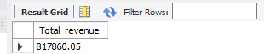

1. **Average Order: select sum(total_price)/count(distinct order_id) Average_order from pizza_sales;**

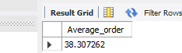

1. **Total Pizzas Sold:** **select sum(quantity) from pizza_sales;**

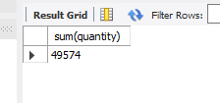

1. **Total Orders:** **select count(distinct order_id) Total_orders from pizza_sales;**

**C:\Users\Elijah Oluwabiyi\Pictures\Camera Roll\Screenshots\Screenshot (357).png**

1. **Average pizzas per order:** **select sum(quantity)/count(distinct order_id) Average_pizzas_per_order from pizza_sales;**

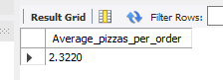

1. **CHARTS REQUIREMENT**
2. **Daily Trend for Total Orders: select dayname(order_date) order_day,count(distinct order_id) daily_count from pizza_sales group by order_day order by daily_count desc;**

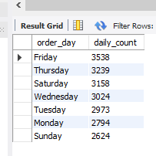**`**

1. **Monthly Trend for Total Orders: select monthname(order_date) order_month,count(distinct order_id) monthly_count from pizza_sales group by order_month order by monthly_count desc;**

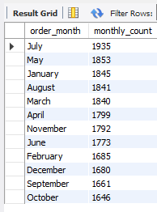

1. **Percentage of Sales by Pizza Category:** **select pizza_category,round(((sum(total_price)/817860.05)*100),2) `percentage of sales by pizza category` from pizza_sales group by pizza_category;**

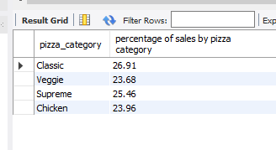

1. **Percentage of Sales by Pizza Size:** **select pizza_size,(sum(total_price)/817860.05)*100 `percentage of sales by pizza size` from pizza_sales group by pizza_size;**

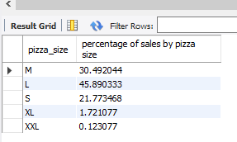

1. **Total Pizzas Sold by Pizza Category:** **select pizza_category,sum(quantity) Total_pizza_sold from pizza_sales group by pizza_category;**

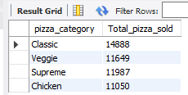

1. **Top Five Best Sellers by Revenue:** **select pizza_name,sum(total_price) `Total revenue` from pizza_sales group by pizza_name order by `total revenue` desc limit 5;**

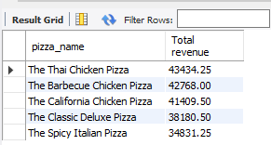

1. **Bottom Five Best Sellers by Revenue:** **select pizza_name,sum(total_price) `Total revenue` from pizza_sales group by pizza_name order by `total revenue` limit 5;**

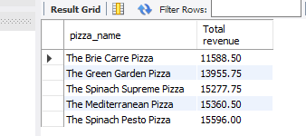

1. **Top Five Best Sellers by Total Quantity:** **select pizza_name,sum(quantity) Total_quantity from pizza_sales group by pizza_name order by total_quantity desc limit 5;**

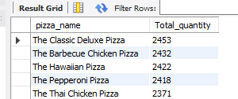

1. **Bottom Five Best Sellers by Total Quantity:** **select pizza_name,sum(quantity) Total_quantity from pizza_sales group by pizza_name order by total_quantity limit 5;**

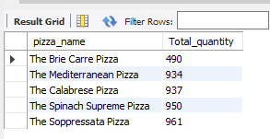

1. **Top Five Best Sellers by Total Orders:** **select pizza_name,count(distinct order_id) Total_orders from pizza_sales group by pizza_name order by total_orders desc limit 5;**

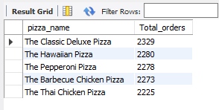

1. **Bottom Five Best Sellers by Total Orders:** **select pizza_name,count(distinct order_id) Total_orders from pizza_sales group by pizza_name order by total_orders limit 5;**

